- $100n+logn ≅n+{(logn)}^{2}$
logn is not steep enough compared to n. So we should compare just 100n and n.
f(g(n)) = $Θ(g\left(n\right))$
- $logn ≅\log\left(n^{2}\right)=2logn$
f(g(n)) = $Θ(g\left(n\right))$
- $\frac{n^{2}}{logn} >n{(\log{n})}^{2}$
As I said logn is not steep enough compared to n.
$$n^{2} >n{(\log{n})}^{3}$$
Then n square is much bigger.
f(g(n)) = $Ω (g\left(n\right))$
- $n^{\frac{1}{2}} {<(logn)}^{5}$
Imagine we put 100 in those functions.
10 < 32
f(g(n)) = O(g(n))
- $n2^{n}< 3^{n}$
$$n< \frac{3^{n}}{2^{n}}$$
f(g(n)) = O(g(n))

- The algorithm is to return the maximum
- Temp1 = T(n/2) + c => it divides the array into half
Temp2 = T(n/2) + c => it also divides the array into half
Therefore the recurrence relation is 2T(n/2) + cn
When we draw the Tree, the height is $\log_{2}^{n}$
So, the constant is $cn\left(\log_{2}^{n}\right)+cn$
level | Level number | Total # of recursive executions at this level | Input size to each recursive execution | Work done by each recursive execution, excluding the recursive calls | Total work done by the algorithm at this level
Root | 0 | 1 | N | cn | cN
One  Level  below  root | 1 | 2 | n/2 | cn/2 | cn
Two  Levels  Below  Root | 2 | 4 | n/4 | cn/4 | cn
The  Level  Just  Above  The  Base  Case  Level | $$\log_{2}^{n}-1$$ | $$2^{(\log_{2}^{n}-1)}$$ | $$\frac{n}{2^{\log_{2}^{n}-1}}$$ | $$\frac{cn}{2^{\log_{2}^{n}-1}}$$ | cn
Base  Case  level | $$\log_{2}^{n}$$ | $$2^{(\log_{2}^{n})}$$ | 1 | c | cn

${nlog}_{2}^{n}$

level | Level number | Total # of recursive executions at this level | Input size to each recursive execution | Work done by each recursive execution, excluding the recursive calls | Total work done by the algorithm at this level
Root | 0 | 1 | N | Cn | cn
One  Level  below  root | 1 | 7 | n/8 | cn/8 | 7cn/8
Two  Levels  Below  Root | 2 | 49 | n/64 | cn/64 | 49cn/64
The  Level  Just  Above  The  Base  Case  Level | $$\log_{8}^{n}-1$$ | $$7^{(\log_{7}^{n}-1)}$$ | $$\frac{n}{8^{\log_{7}^{n}-1}}$$ | $$\frac{cn}{8^{\log_{7}^{n}-1}}$$ | $$\frac{7^{\log_{7}^{n}-1}*cn}{8^{\log_{7}^{n}-1}}$$
Base  Case  level | $$\log_{8}^{n}$$ | $$7^{(\log_{7}^{n})}$$ | 1 | c | cn
T(n) = cn(1/(1-7/8) = 8cn

- Base case proof
T(1) = O(n)
As T(1) = 5, T(1) = O(n)
- Inductive hypothesis
T(k) = O(k)
For some c and N for all n>N i.e. T(k) < 차
- To prove
T(K+1) = O(K+1)
Using induction
T(K+1) < 3CK/3 + 5
T(K+1) < C(K+1) + 5 -C
When c = 5,
- T(K+1) < C(K+1)

If
S(n) = $n^{4}+n^{2}$
f(n) = $n^{4}$
r(n) = $n^{4}-n^{2}$
g(n) = $n^{4}$
Therefore, f(n) = O(s(n)), g(n) = O(r(n))
- f(n) – g(n) = 0 = O(1)
- O(s(n) -r(n)) = O($n^{4}+n^{2}- {(n}^{4}-n^{2}))$
- Therefore, $f\left(n\right)-g\left(n\right) ≠ O(s\left(n\right)-r\left(n\right))$

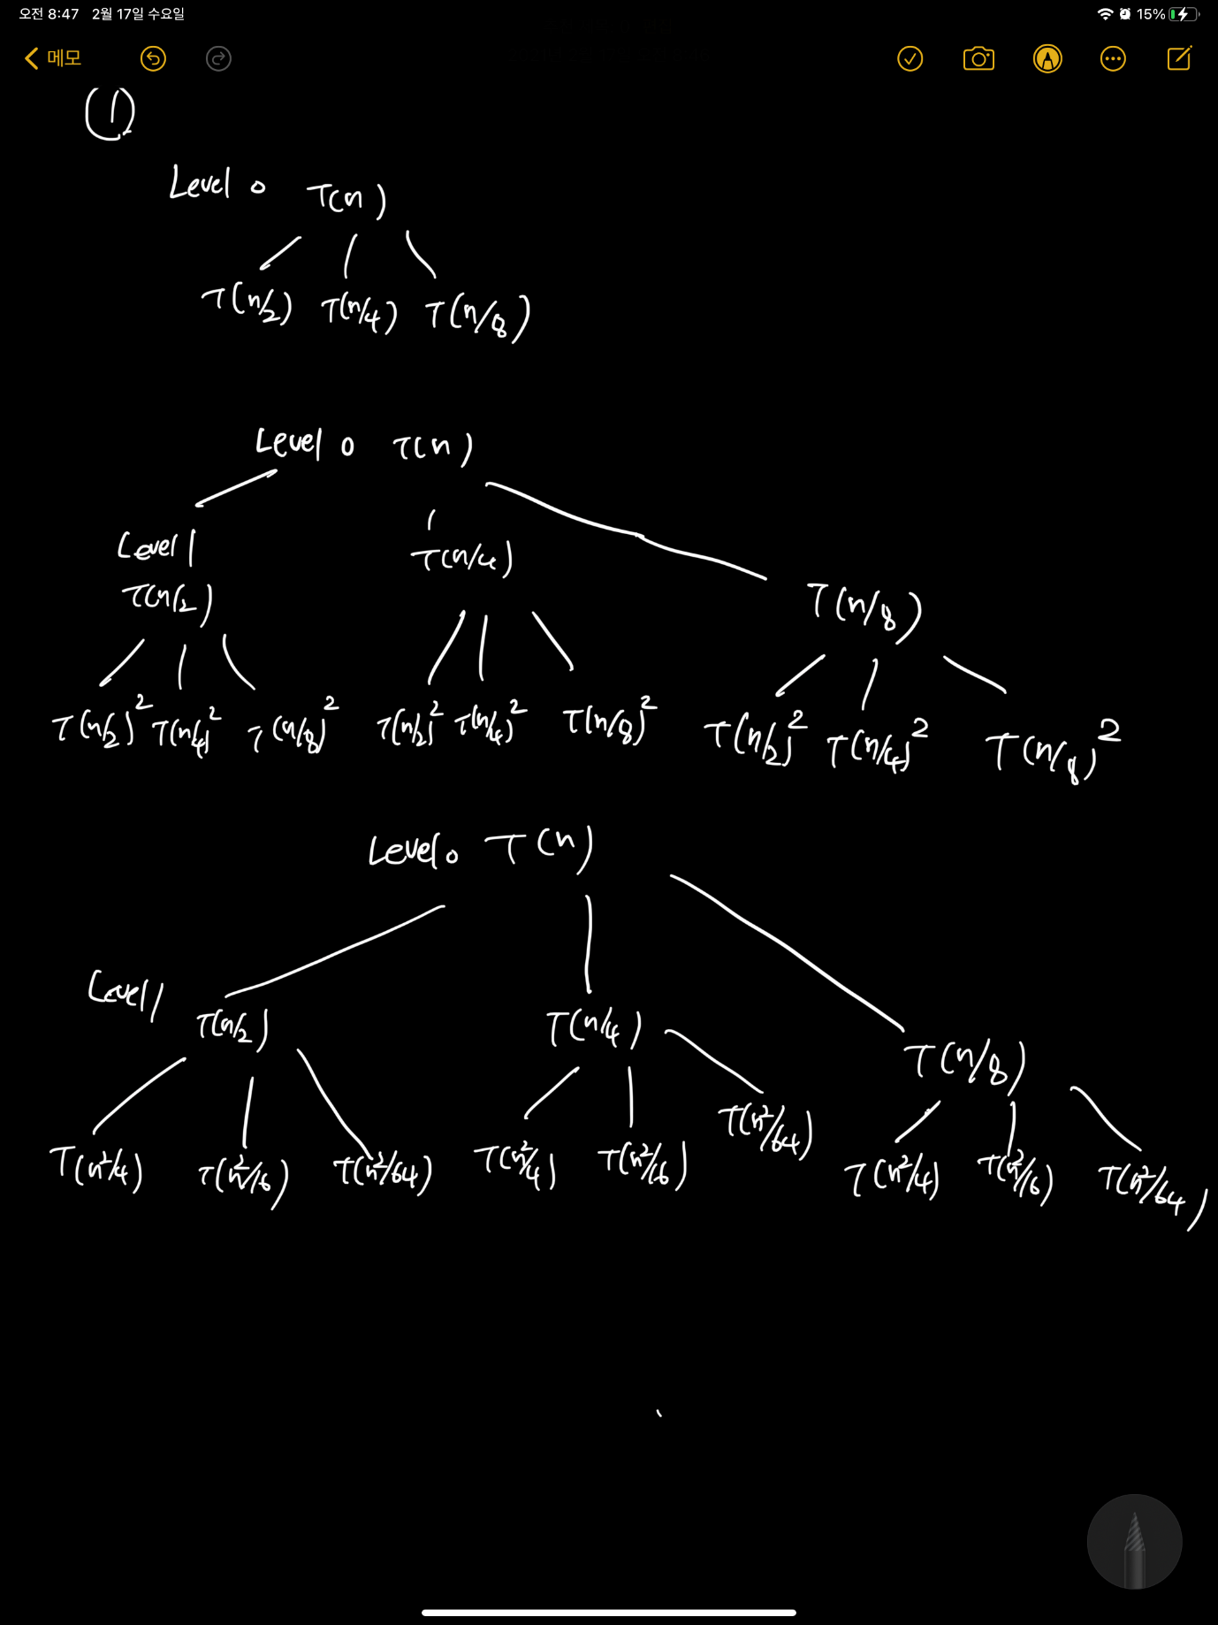

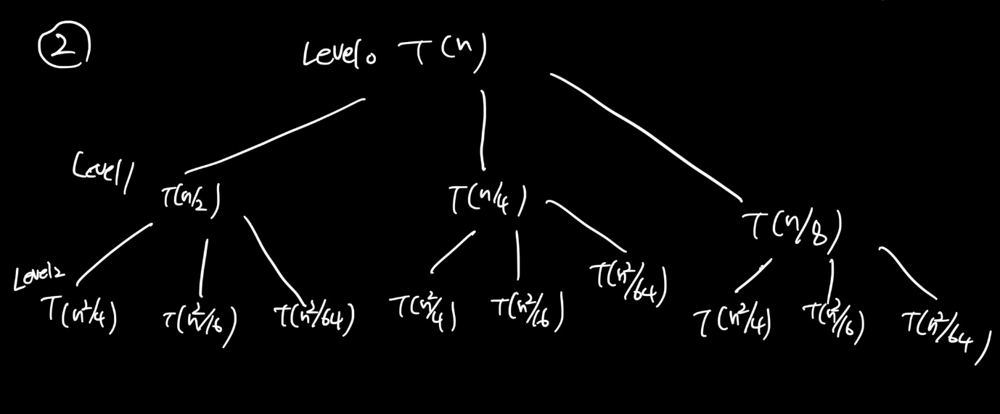

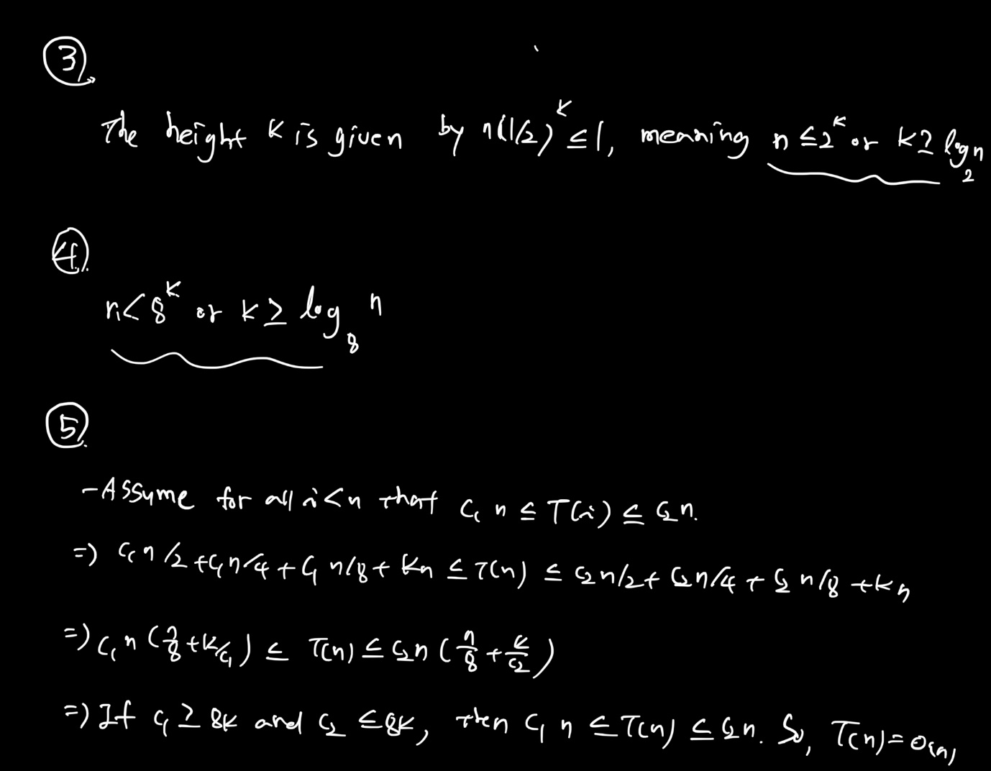

Statement of what you have to prove :
We have to show that T(n) = O(n) for T(n) = T(n/2)+ T(n/4) + T(n/8) + T(n/8) + n; T(1) = c.
Base case proof:
Assume that T(n) = c *n for some c which is bigger than 0. Let n =1, c =1. We have T(1) = 1 = c.

Inductive Hypothesis :
T(n) = T(n/2)+ T(n/4) + T(n/8) + T(n/8) + n
= c(n/2) + c(n/4) + c(n/8) + c(n/8) + n
= 7/8 cn+ n =n (7/8 c +1)

Inductive Step :
We now should find a constant that is into formula above.
C = (7/8c + 1) -> c = 8 -> 7/8 (8) + 1 = (7 + 1) = 8. There fore, c = 8 and T(n) = 8c
- T(n) = O(n)

- T(n) = 2T(99n/100) + 100n
= 198T(n/100) + 100n
Based on the Masters theorem, a = 198, b = 100, c = 1, f(n) = 100n
$$\log_{b}^{a}=\log_{100}^{198}$$
$$\log_{100}^{198}>1=c$$
- T(n) = $θ\left(n^{\log_{b}^{a}}\right)= θ(n)$

Based on the Masters theorem, a = 16, b = 2, c = 3, k = 1
$$\log_{b}^{a}=\log_{2}^{16}>3=c$$
- T(n) = $θ\left(n^{\log_{b}^{a}}\right)= θ(n^{4})$

Based on the Masters theorem, a = 16, b = 4, c = 2
$$\log_{b}^{a}=\log_{4}^{16}=2=c$$
- T(n) = $θ\left(n^{2logn}\right)$

(1)
T(n) = 2T(n-1)+1
T(1) = 2T(0)+1 = 3 = $(2^{n+1}-1)$
T(2) = 2T(1)+1 = 7 = $(2^{n+1}-1)$
T(3) = 2T(2)+1 = 15 = $(2^{n+1}-1)$
(2)
T(n) = 2T(n-1) + 1 => 2(2T(n-2)+1)+1
= 4T(n-2) + (1+2)
=4(2T(n-3)+1)+3
=$2^{n}T\left(0\right)+(1+…+2^{n-1})$
= $2^{n+1}-1$
(3)
- Base case
N = 0, T(0) = 1
- Let’s assume that T(k) = $2^{k+1}-1$ for k >0
T(k+1) = 2T(k)+1 = same.
Proved.
(4)
Because the order is $2^{n}$, it will have $2^{n}$ times operations to show the output.

T(n) = T(n-1) + n/2
= T(n-2) + ((n-1)+n)/2
- T(n-k) + ((n-k+1)+(n-k+2)+…+n)/2
Put k = n – 1
= T(1) + (2+3+…+n)/2
= 1+(1+2+3+…+n-1)/2
= $\frac{n(n+1)}{4}+\frac{1}{2}$

T(n) = 2T(n/2) + $2n\log_{2}^{n}$
- 2(2T(n/4) + 2(n/2)$\log_{2}^{n/2})+2n\log_{2}^{n}$
- 4T(n/4) + 4n$\log_{2}^{n}-2n$
- 8T(n/8) + 6n$\log_{2}^{n}$-6n
- $2^{k}T\left(\frac{n}{2^{k}}\right)+2kn\log_{2}^{n}-2kn$
For $\frac{n}{2^{k}}=2 , 2^{k}=n/2$
= n/2 * T(4) + 2($\log_{2}^{n}-1)n\log_{2}^{n}-2(\log_{2}^{n}-1)n$
= 2n + 2($\log_{2}^{n}-1)n\log_{2}^{n}-2(\log_{2}^{n}-1)n$
- O(nlog₂²n)

O(n^2) is the worst case running time. Therefore, when we use it, we should say “at most” rather than “at least”. Because it implies the upper bound.

